Siskiyou Room, Community Development and Engineering Building, 51 Winburn Way
Tuesday April 9, 2024 * 5:30 – 7:30 p.m.

AGENDA

CALL TO ORDER: 5:30 p.m., Meeting held in person (no Zoom option this time)

- Welcome & Agenda Review (5:30-5:35 p.m.)

- Public Forum and Announcements (5:35-5:40 p.m.)
Up to 5 minutes allotted for public comment.

- Debrief of City Council Study Session (5:40-5:45 p.m.)

- Comments from Council Liaisons (5:45-5:50 p.m.)
Communications with or from Council about the work of the Subcommittee

- Approval of Minutes (5:50-5:55 pm.)

- Updates on Services Inventory (5:55-6:00 p.m.)
All forms due by Friday, April 12

- Review Revised Timeline (6:00-6:10 p.m.)

- Review and SWOT Analysis of the CoC (6:10-6:55 p.m.)

- Finalizing Community Outreach Plans and Communications (6:55-7:20 p.m.)

- Debrief (7:20-7:30 p.m.)
  - Takeaways
  - Pluses and Minuses (What went well tonight? What do you wish were different?)

- ADJOURNMENT: 7:30 PM

Next Meeting Dates: Wednesday, April 24 and Tuesday May 14

In compliance with the Americans with Disabilities Act, if you need special assistance to participate in this meeting, please email linda.reid@ashland.or.us. Notification 72 hours prior to the meeting will enable the City to make reasonable arrangements to ensure accessibility to the meeting (28 CFR 35.102-35.104 ADA Title 1).

Timeline (revised 4/4/24)

Date | Meeting | Topics | Follow-up Tasks
2/28 | Subcommittee | Understanding the players addressing homelessness
 |  | Subcommittee Approach, Tasks, and Timeline | Share with HHSAC and City Council
 |  | Assignments to complete Service Inventory | Gather information
 |  | Communications with HHSAC and City Council | Provide written materials
 | HHSAC | Subcommittee Approach, Tasks, and Timeline
 | City Council | Subcommittee Approach, Tasks, and Timeline
3/12 | Subcommittee | The Responsibilities of a Continuum of Care (CoC) | Gather additional information
 |  | Final preparations for Program/Service Inventory work | Gather information
3/27 | Subcommittee | Updates on Program/Services Inventory and data gathering | Continue to gather information
 |  | Determine which subpopulations to engage in providing community perspectives and who will engage each population
 |  | Develop engagement plans for each subpopulation
 |  | Communications with HHSAC and City Council | Provide written materials
3/28 | HHSAC | Community Engagement plans
4/1 | City Council | Community Engagement plans
4/9 | Subcommittee | Finalize questions/tools for each subpopulation | Prepare tools. Set up mechanisms, promote opportunities
 |  | Review progress on Services Inventory | Confirm deadline 4/12
 |  | Review CoC information; discuss strengths, weaknesses, and potential opportunities | Collect any additional information
4/24 | Subcommittee | Review Services Inventory and identify barriers to accessing services | Prepare for SWOT
 |  | Data presentation – part 1
 |  | Update on Community Input process | Confirm deadline 5/7
5/14 | Subcommittee | Review public input; identify themes | Prepare summary
 |  | Data presentation – part 2
5/22 | Subcommittee | Services Inventory SWOT Analysis
 |  | Review summary of Community Input; affirm community perspectives, themes, and priorities
6/11 | Subcommittee | Review draft report, including framework for money map. Suggest revisions. | Finalize report
 |  | Discuss format for reporting to HHSAC and City Council | Prepare for reporting to HHSAC and Council
6/26 | Subcommittee | Review final report | Final adjustments
 |  | Confirm plans for reporting to HHSAC and City Council | Final preparations
tba | HHSAC | Subcommittee Report
tba | City Council | Subcommittee Report

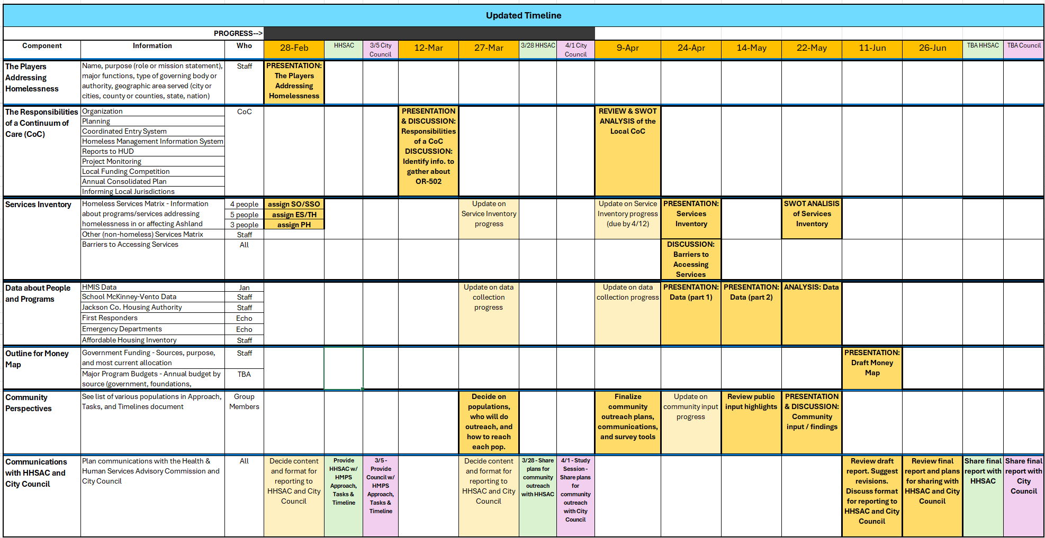

Last updated 4/4/24

